WAMS - Advanced applications FOR DISTRIBUTION

A. POPELKA, AIS, Czech Republic
F. VYBÍRALÍK, CIRED, Czech Republic
D. JUŘÍK, AIS, Czech Republic
M. KRSTIČ, AIS, Serbia

SUMMARY

Wide Area Monitoring Systems (WAMS) are based on synchronous measurement of phasors of electric quantities with very precise time synchronization. The synchrophasors measured in the same time in the entire network allow realization of many functions for support of development and control of distribution networks. Such functions had no solution in the real operation till now.
This paper shows some applications and documents results of their function.

Key words: Wide Area Monitoring System, WAMS, PMU, synchrophasor, Line Parameters, Ampacity, Dynamic Rating, Network splitting, Network reconnection, Islanding, Voltage Stability, System stability.

SUPPORT OF SAFE SWITCHING IN DISTRIBUTION NETWORKS

The WAMS function for support of switching in distribution networks is based on measurement in the selected network places. The application allows selection of arbitrary measurement location as a reference place and recalculation of measurements from other places with relation to the selected reference. Information about angle differences and estimation of current flow in the case of switching is immediately available to the dispatcher.
Dispatcher can use the provided information either for common switching tasks or also for switching in ring, switching in grid network and restoring of operation after shortage.

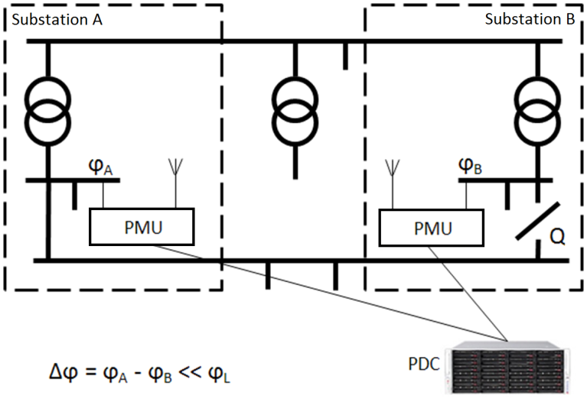
Fig. 1. Typical measurement scheme for the support of switching.

MONITORNG OF LINE PARAMETERS

The method principle

Measurement of voltage and current synchrophasors in both line ends is required for the determination of line parameters according to the scheme in Fig. 2. The synchrophasor data are transferred to the central station PDC (Phasor Data Concentration) and stored in the database. Calculation of line parameters is performed by a special application using the database data. Monitoring of line parameters are performed online under common operational conditions and changing weather.

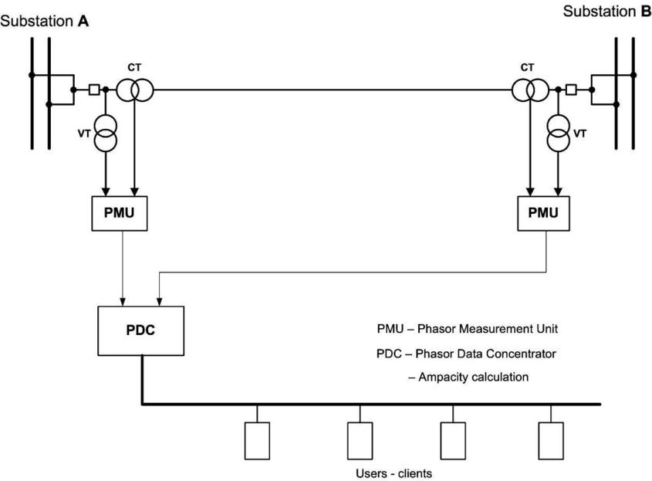
Fig. 2. Scheme of measurement of line parameters

Equivalent line scheme is assumed as π-cell. The following formulas are used for the calculation of longitudinal impedance Z and shunt admittance Y in complex form using voltage and current synchrophasors measured in both line ends.

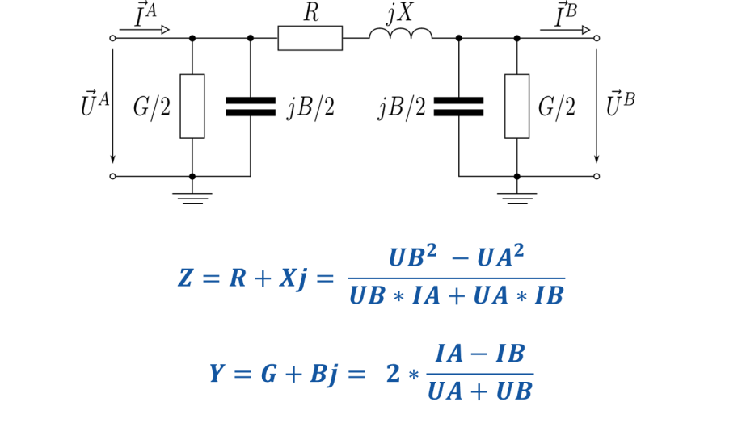
Fig. 3: Equivalent line scheme and formulas for calculation of line parameters

The line quality

The age of lines used in the network can vary from entirely new line up to tens of years. The quality of line changes during line operation and these changes are reflected in the changes of electric line parameters:
X – Reactance corresponds mostly to construction parameters, geometry of individual phases and diameter of conductors.
R – Line resistance is defined as construction parameter R0 or R20 representing resistance at temperature of 0˚C or 20˚C. Temperature coefficient of resistance is usually not stated. Value of line resistance is subject to aging due to corrosion and breaking of individual strands in the line. The line resistance also varies with changes of ambient temperature.
B – Line capacitance depends on geometry of conductors, height of conductors above ground and distance between conductors and surroundings (trees, buildings). Capacitance almost doesn’t depend on the line age.
G – Conductance (shunt conductivity) is defined as reciprocal value of the insulation resistance between conductors and ground. This value is subject to aging most of all parameters. Conductance can be increased due to higher conductivity of insulator surfaces caused by dirt, smoke, exhalations etc. Breakdowns and disruption of internal homogeneity of insulators also represent significant influence. Conductance is further affected by weather conditions and humidity of air and insulator surface. It is obvious that the line quality is mostly represented by this parameters and a change of line conductance can be measure of the entire line quality. The conductance is commonly so low that it is mostly not considered. Increased conductance indicates deteriorating line quality.

The line temperature

The series effective resistance of line is clearly bound to the line temperature. Line temperature depends on weather conditions and flow of electric current through the line. Ambient temperature and thermal effects of sun radiation are dominant influences. Effective resistance of line truly reflects the line temperature and its trend. Fig. 4 shows example of measurement of line and ambient temperatures. Contribution of solar radiation in the daytime is obvious.
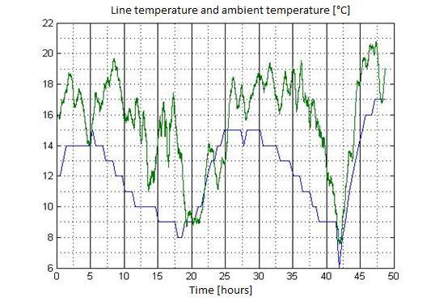
Fig. 4: Example of line and ambient temperature

LINE TRANSFER CAPACITY – AMPACITY

The line ampacity is defined as the highest current that will not disrupt technical and safety limits. This application requires measurement of voltage and current synchrophasors in both line ends. The application evaluates series line resistance and average line temperature and calculates line ampacity and reserve above the static limit. The application allows usage of reserve in line operation and utilization of reserve in the use of power networks.

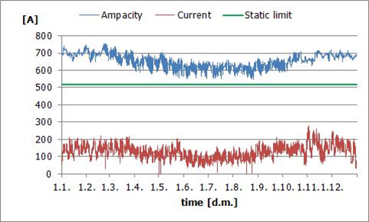
Fig. 5: Example of line current and calculation of ampacity

OTHER WAMS APPLICATIONS

Other applications of WAMS provide functions related to transmission of electric power, however, some of them can be utilized in distribution as well.

Detection of island operation

This application is based on measurement of synchrophasors in selected network nodes. Its aim is to provide supervision of network integrity with monitoring of frequency and angle differences. The application also detects separation of network parts, allows monitoring of separated parts and provides support for synchronization process. This application is one of basic functions of developed SmartGrids.

Estimation of network state

This application of WAMS represents significant addition to the estimation data set and contributes to more exact and reliable estimation results. Synchronous data from WAMS eliminate calculation errors caused by non-synchronous measurements. The data measured by WAMS can be transferred to the estimation software in SCADA or it is also possible to place the estimation software directly in the WAMS system.

Monitoring of complex voltages and currents, monitoring of frequency

This function represents advanced application allowing analysis of occurrence and progress of transient states and failures. This application also provides quality data for network modeling and simulation, contingency analysis and further PAS calculations.
On-line monitoring of frequency allows detection of interarea frequency and power oscillations, modal and frequency analysis of measured data and detection of critical state with alarm generation.

Evaluation of static network stability, monitoring of voltage stability

This applications continuously evaluates static stability and generates warning in the case of low reserve of stability or in the danger of network disintegration.
The voltage stability function continuously evaluates voltage dependence of the transmitted power (P-V curve) and generates warning in the case of critical state.
Outputs from these applications can help in assessing the influence of unpredictable sources (photovoltaic power stations, wind farms). Monitoring of inter-area oscillations of frequency and power is also possible. Next suggestions are in [5].

CONCLUSION

The quality of data obtained by WAMS systems allow monitoring of operation and state of the entire network in real time and creation of expert systems for improvement of security of power networks and prevention of critical states like blackout.
Application functions of WAMS use the measured data for analysis of behavior of network and its components and provide various types of outputs including generation of events and alarms on exceeding of predefined limits, analysis of quality of network components, analysis of real transfer capacity of lines and analysis of real losses in the network.
Synchrophasor data and outputs of application functions are available for usage in further analysis or in related systems e.g. SCADA.
WAMS represents a new modern approach to the solutions that significantly improve functions and possibilities of traditional SCADA/EMS systems.
Many information about WAM Systems and their applications are available e.g. on the web site of North American SynchroPhasor Initiative [5].

LIST OF REFERENCES

1. Popelka A, Juřík D, Marvan P, 2010, Actual line ampacity rating using PMU, CIRED Frankfurt 2010
2. Popelka A, Juřík D, Marvan P, Povolný V, 2013, ADVANCED APPLICATIONS OF WAMS, CIRED Stockholm 2013
3. IEEE Std C37.118-2005, IEEE Standard for Synchrophasor Measurement for Power Systems
4. IEEE Std C37.118-2011, IEEE Standard for Synchrophasor Measurement for Power Systems
5. https://www.naspi.org/
6. Sexauer J., Javanbakht P., Mohagheghi S., Phasor Measurement Units for the Distribution
Grid: Necessity and Benefits, Proceedings of IEEE Innovative Solutions for the Smart Grid (ISGT), February 2013

